Home Work #1

Saad Ahmad

20P-0051

**Question #1**

Router Modes:

User EXEC Mode:

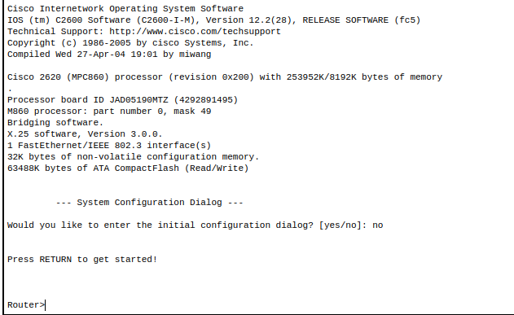

Privileged EXEC mode:

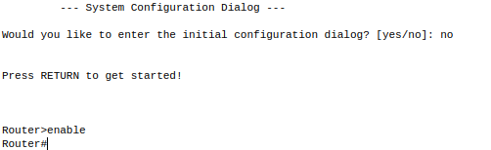

Global Configuration mode:



**Question #2**

Changing Hostname of the Router:

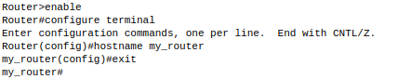

**Question #3**

Configuring Date and Time on the Router (Clock Set Command)

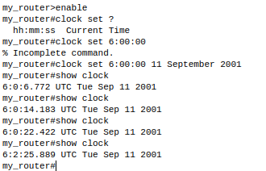

**Question #4**

Setting a banner on the Router

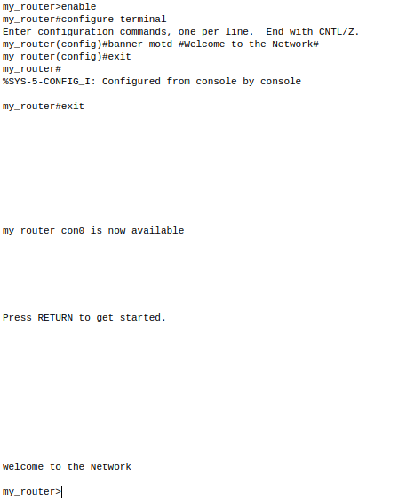

**Question #5**

Displaying the Router’s Running-Configuration and Start-Up Configuration

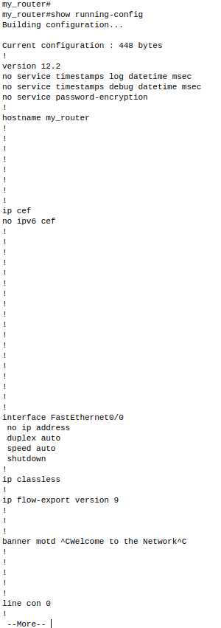

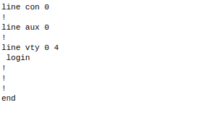

**Question #6**

Enable Password and Enable Secret Password with the Encryption Techniques/Levels

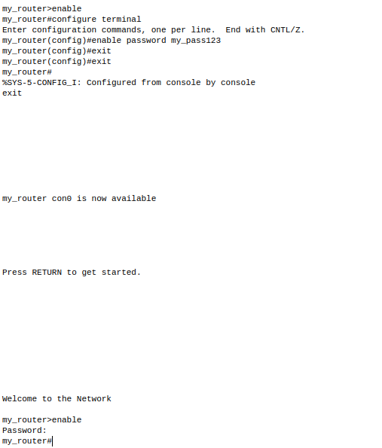

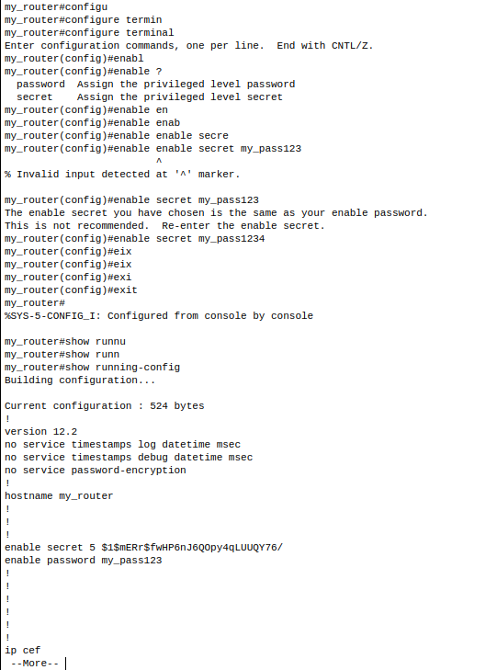

**Question #7**

Line Console Password Implementation on CISCO 2600 Series Router

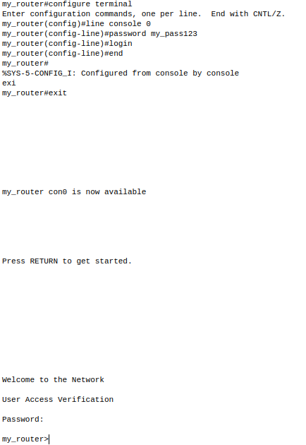

**Question #8**

What is Telnet? How to Telnet? + Line VTY/Telnet Password

Telnet is a network protocol used to virtually access a computer and to provide a two-way, collaborative

and text-based communication channel between two machines. It follows a user command Transmission

Control Protocol/Internet Protocol (TCP/IP) networking protocol for creating remote sessions.

You can Telnet into a router using the Telnet client included with Windows. ... Unlike other

protocols, Telnet isn't secure and shouldn't be used over the Internet. For example, typing telnet hostname would connect a user to a hostname named hostname. Telnet

enables a user to manage an account or device remotely.

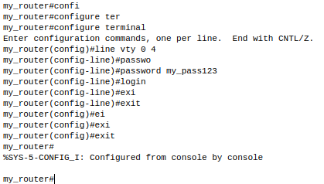

**Question #9**

Usage of Router with different topology.

* Media, signal, and binary transmission
* Physical addressing
* Path determination and logical addressing
* End-to-End connection and reliability
* Interhost communication
* Data representation and encryption
* Network process to application.